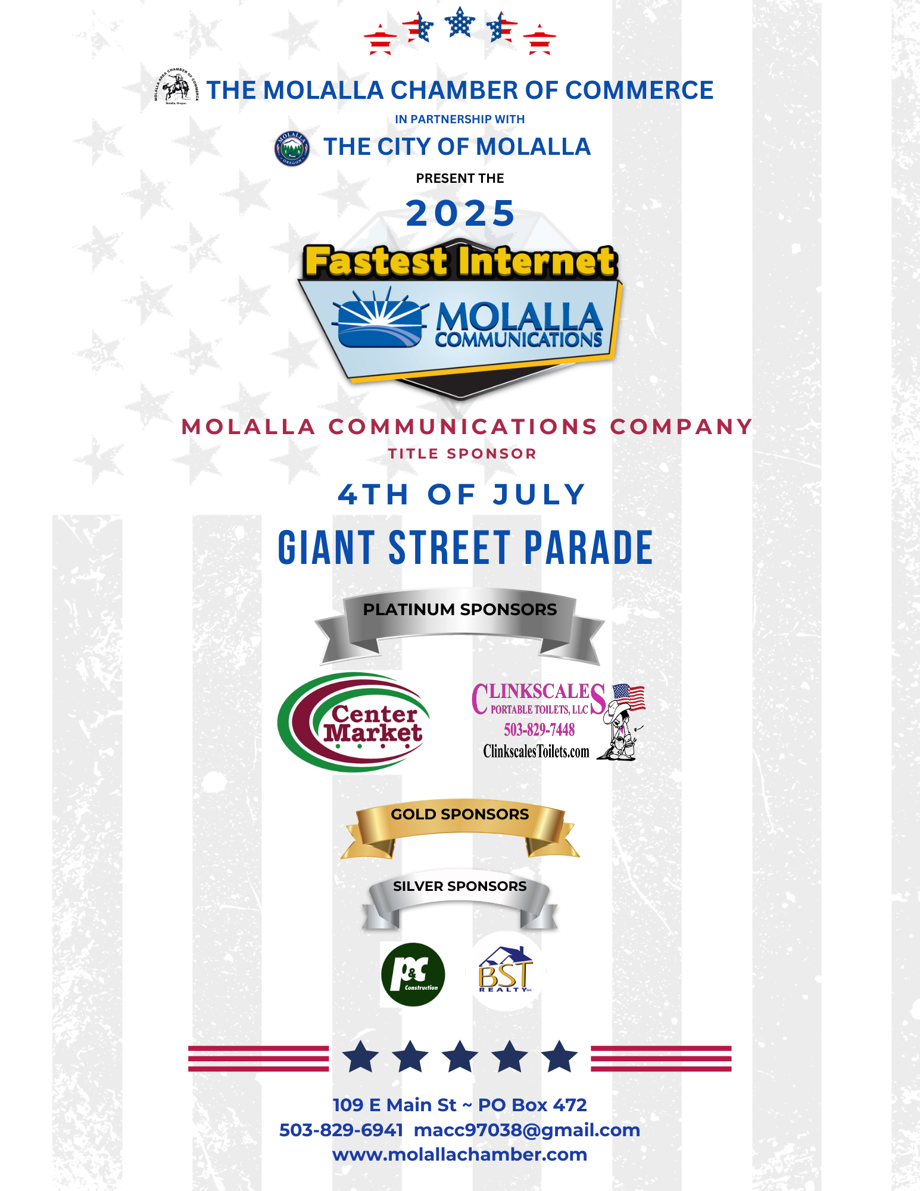

Parade Information

The rules and regulations are designed with safety issues in mind. Alcohol, other intoxicants, and drugs are not allowed in any staging area or in the parade. Anyone giving the resemblance of being under the influence of narcotics or intoxicants will be asked to leave and will forfeit all entry fees and/or prizes. The Molalla Area Chamber of Commerce reserves the right to refuse entries that do not meet the specifications as set forth in the rules and regulations.

Entries violating the rules and regulations are subject to removal from the Parade by any Law Enforcement Officer, Fire Department Personnel or Parade Official and/or disqualification of participation in future parades.

Standard Entry Closes June 25th Late entry after June 25th will be $10 higher

No entries will be accepted after July 1st

A single entry may consist of no more than one (1) power unit.

Parade Information

The rules and regulations are designed with safety in mind. Alcohol, other intoxicants, and drugs are not allowed in any staging area or in the parade. Anyone giving the resemblance of being under the influence of narcotics or intoxicants will be asked to leave and will forfeit entry fees and/or prizes. The Molalla Area Chamber of Commerce reserves the right to refuse entries that do not meet the specifications as set for in the rules and regulations.

Entries violating the rules and regulations are subject to removal from the parade by any Law Enforcement Officer, Fire Department Personnel or Parade Official and possible disqualification of participation in future parades.

STANDARD ENTRY CLOSES JUNE 25TH LATE ENTRY AFTER JUNE 25TH WILL BE $10 HIGHER

NO ENTRIES WILL BE ACCEPTED AFTER JULY 1ST.

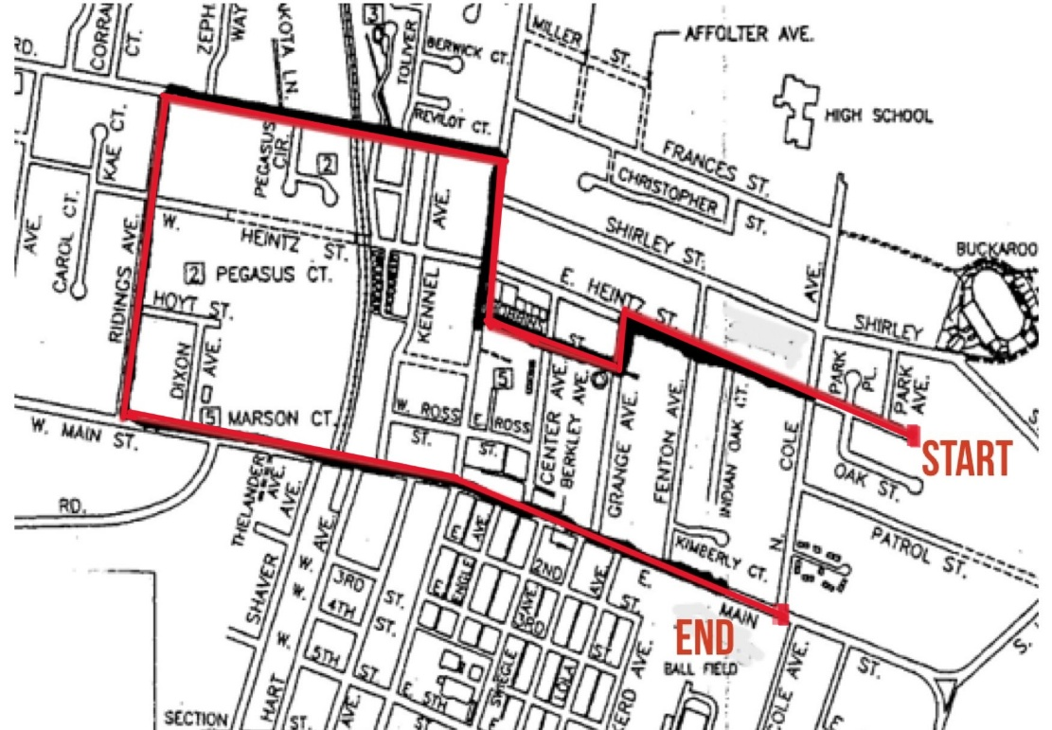
A single entry may consist of no more than one (1) power unit.

Commercial/Business☐ $85.00 (all entries with a business name or logo displayed)

Community/Personal/Non-Profit ☐ $50.00 (all non-business entries EXCEPT personal auto and equestrian)
Personal Auto☐ $30.00 Equestrian☐ $25.00

THE VEHICLE PULLING YOUR FLOAT IS INCLUDED IN THE FEE

A support vehicle IN ADDITION to the vehicle pulling your float will be $15.00 and only one may be added.

If you have any questions, please call the office for assistance (503) 829-6941

Please check ONE entry in ONE category that best describes your entry ± Indicates non-judged category.

Automobiles, Pickups - Proof of Insurance Needed (Upload at end of application) $85 Business $30 Personal/Community
Auto clubs will be charged $30.00 for the group and $10 for each additional vehicle
☐ Vintage Car to 1955 ☐ Classic Car 1956-1979 ☐ Rat Rod ☐ Auto Clubs # of vehicles _____
☐ Classic Pickup 1956-1979 ☐ Commercial Auto ☐ Misc.

Novelty/Miscellaneous $85 Business $50 Personal/Community
☐ Motorcycle/ATV ± ☐ Boats/Jet ski ± ☐ Golf Carts ± ☐ Custom/Novelty ☐ Hobby/Personal Tractor
☐ Military Vehicle ± ☐ Dignitaries ± ☐ Royalty (Auto) ± ☐ Bicycles ± ☐ Misc

Trucks/Heavy Equipment/Specialty Rigs Proof of Insurance Needed (Upload at end of application)
$85 Business $50 Personal/Community
☐ 18-Wheeler/Heavy Equipment/Specialty Rig ☐ Commercial Tractor ☐ Public Service Vehicles

Equestrian $25
☐ Royalty ☐ Costume ☐ Western ☐ Youth ☐ Horse Drawn ± ☐ Posse/Saddle Clubs/Drill Team ±
Age limitations: The Equestrian Youth Categories are for youth 16 & under. ALL EXCEPTIONS MUST BE APPROVED. Youth must be accompanied by an adult. Youth under age 10 must be led by an adult.

Posse/Saddle Clubs: An organized posse or saddle club.
Drill Team: Group of riders who perform choreographed routines.
Horse Drawn: Any equestrian unit pulled by a horse or a team of horses.

Floats $85 Business $50 Personal/Community/Church
☐ Commercial ☐ Community/Family ☐ Church

Band/Marching/Drill/Cheer $85 Business $50 Personal/Community
☐ Dance Teams/Drill Teams & Cheer ☐ Bands ± ☐ Military/Drill Teams ± ☐ Walking Units ±

Release of Liability

I desire to voluntarily participate in the 4th of July Molalla Giant Street Parade (the “Parade”) upon my own initiative, risk and responsibility. In consideration for permitting me to participate in the Parade, I hereby release and forever discharge the Molalla Area Chamber of Commerce, Sponsors, the Molalla Buckeroo Association, the City of Molalla, their officers, agents, their individual and business members, their successors and assigns (collectively the “Released Parties), acting officially or otherwise, from any and all claims, demands, actions or causes of action (a “Claim”), on account of my death, injury of loss of any sort, or on account of the death or injury to any family member or any animal owned by me which may occur as a result of or arise from my participation in or preparation for the parade, regardless of how arising, including any such Claim resulting from the negligence of a Released Party.

This release also includes any Claim for damage or loss of any vehicle, trailer, horse or float owned, managed, or operated by me and includes any preparation for the Parade, any movement to, from, or during the Parade.

I further represent that any vehicle, trailer, or float that I enter and/or operate in the Parade is safe with no known mechanical or safety defects, for which I will inspect. I will not operate, nor will I allow the operation of any vehicle, trailer or float owned or operated by me in an unsafe or reckless manner.

If my entry includes animals, I agree the animal(s) will be kept under control at all times, before, during and after the Parade. I am aware that any animal(s) can be removed from the Parade by any Fire Department Representative, Parade Official, or Public Safety Officer for any reason, including if the animal is deemed to be out of control or a danger to any other participant and/or spectator.

I further represent that I will defend, indemnify and hold harmless the Released Parties, acting officially or otherwise, from all Claims, demands, actions or causes of action which may arise or result from or out of my/our participation for Parade activities, including but not limited to, Claims from any person who rides in or on or around my vehicle, trailer, horse and/or float. This release is binding on my heirs, successors, assigns, executors, administrators, and personal representatives.

I have read and understood the above Agreement and agree to abide by the terms set forth.

Click or tap here to enter text. Click or tap to enter a date.
Printed Name | Date

Click or tap here to enter text. Click or tap to enter a date.
Signature (Typed name is your electronic signature) | Date

Click or tap here to enter text. Click or tap to enter a date.
Parent or Guardian of minor | Date

Rules and Regulations

Please initial in the box next to each of these rules, even if you think they do not apply to you.

Application: Filled out completely. One category is chosen. Liability Release is signed.
Insurance: Proof of Insurance is included for trucks and autos.
Drivers: A licensed adult over 21 will operate all towing vehicles, autos, trucks, or equipment.
Entry Check in: Entry Number will be displayed.
Attendance: All parade entries must be attended at ALL times.
Participants: Participants may not get on or off floats, horses, tractors, or other conveyances for the entire parade
drivers must remain in the vehicle they are driving.
NO stopping to perform: All entries must stay within 30 feet of each other. Entries must be moving forward, motion
must be maintained.
Searches: All entries are subject to searches within reason by the Molalla Police or other Law Enforcement Agency.
Fireworks/poppers: No fireworks or poppers allowed.
Firearms or projectile weapons: No firearms or projectile weapons of any type real or “play” (including water, nerf or
air soft guns are allowed. The only exceptions will be firearms carried by a recognized miliary honor guard or active,
recognized U.S. Military personnel with a special permit issued by the Molalla Police Department.
No Flammables: Entries may not emit any flame or flammable substances.
Tractors/Mowers: Any unit equipped with a mower deck must have the deck locked in place and blade disengaged.
ATV & Motorcycle Limitations: Operator/driver must be a legally licensed driver or person over age 16 with proof of
training in an accredited ATV course. Helmets must always be worn.
Motorized “toy” vehicles operated by children aged 15 and under must be equipped with a remote-control power kill
switch. An accompanying parent must be in physical control of said remote at all times. Proof of the kill switch and
workability must be demonstrated on the morning of the 4^{th,} or the entry will not be allowed to proceed in the parade.
Entry must be able to travel the entire parade route and maintain a speed up to 3 miles per hour.
No excessive speed: At no time may there be a display of excessive speed or power by any motor vehicle.
Dogs: Dogs must always be kept on a leash and under the control of their handler. Those not under control are subject
to removal.

Business Name: Click or tap here to enter text.

Contact Name: Click or tap here to enter text.

Mailing Address: Click or tap here to enter text.

City, State, Zip: Click or tap here to enter text.

Phone Number: Click or tap here to enter text.

Email Address: Click or tap here to enter text.

Signature: I acknowledge receipt of the attached rules and regulations and agree to comply.

Click or tap here to enter text. Click or tap to enter a date.
Signature (Typed name is your electronic signature) Date

Make checks payable to:
Molalla Area Chamber of Commerce
109 E. Main St. / PO Box 472
Molalla, OR 97038
503-829-6941
macc97038@gmail.com

Registration will be processed after receipt of completed applications, proof of insurance and receipt of payment.
Payments may be mailed, dropped off or paid on our website.
Link to pay online: https://www.molallachamber.com/chamber-store

I paid my entry fee on: Click or tap to enter a date. Payment Method: Choose an item.

Arrival & Exit/Departure Instructions

YOU MUST HAVE YOUR ENTRY NUMBER DISPLAYED TO CHECK IN
(Replacements are $5.00 at the check in location)

CHECK IN:
Begins at 7:00 am – Closes at 8:45 am
(Entries wishing to be judged must arrive before 8:00 am)
at Bohlander field across from Buckeroo Grounds on Shirley St.

Participants may be dropped off at the gate on Shirley Street.
Parents dropping off small children may park in the designated parking area inside the gate.
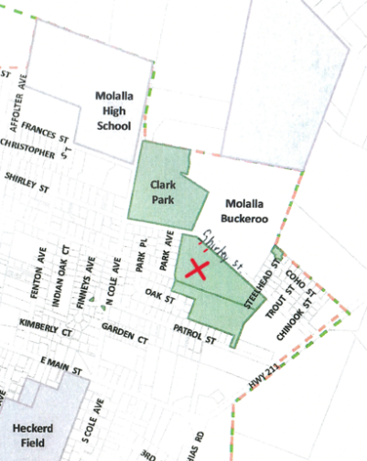
BOHLANDER FIELD

DEPARTURE
The Parade ends on Main St. as you approach the grass parking lot of Heckard Field just before Cole St.
Vehicles will continue straight on Main St.
Equestrian entries will turn left on Cole and turn right on Heintz to return to Bohlander field.
Instructions for walkers and bikers are coming soon.
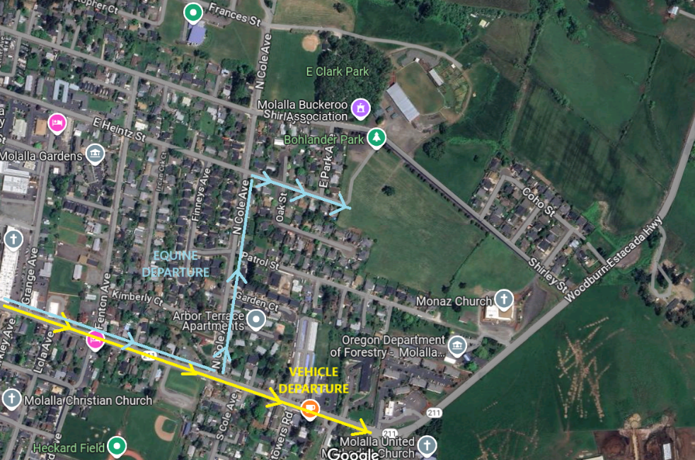
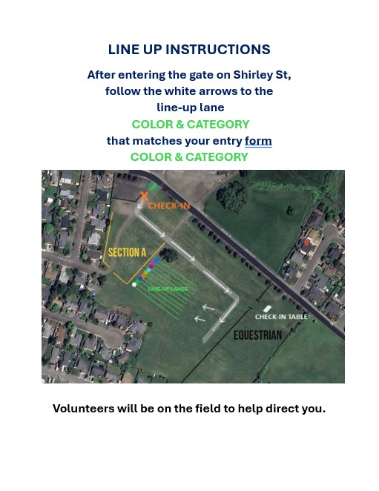

Proof of Insurance

Commercial: Upload Certificate of Insurance
(REQUIRED FOR COMMERCIAL ENTRIES)



Car or Truck: Upload Insurance Card

