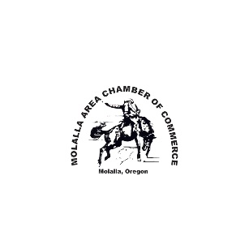
The Molalla Area Chamber of Commerce

In Partnership with

The City of Molalla
Our Platinum Sponsors

Interfor Clinkscales Portable Toilets

Present:

THE “SMALL TOWN U.S.A.”
2023 Giant Street Parade

B & B Leasing as our Gold Sponsor

Molalla Communications & BST Realty as our Silver Sponsors

Entry Form Packet
503-829-6941
Macc97038@gmail.com

Parade Information

The rules and regulations are designed with safety issues in mind. Alcohol, other intoxicants, and drugs are not allowed in any staging area or in the parade. Anyone giving the resemblance of being under the influence of narcotics or intoxicants will be asked to leave and will forfeit all entry fees and/or prizes. The Molalla Area Chamber of Commerce reserves the right to refuse entries that do not meet the specifications as set forth in the rules and regulations.

Entries violating the rules and regulations are subject to removal from the Parade by any Law Enforcement Officer, Fire Department Personnel or Parade Official and/or disqualification of participation in future parades.

Standard Entry Close June 23 Late entry after June 23rd will be $10 higher.

No entries will be accepted after June 27th.

A single entry may consist of no more than one (1) power unit.

Return the initialed rules & regulations with the application.

2023 Parade Route

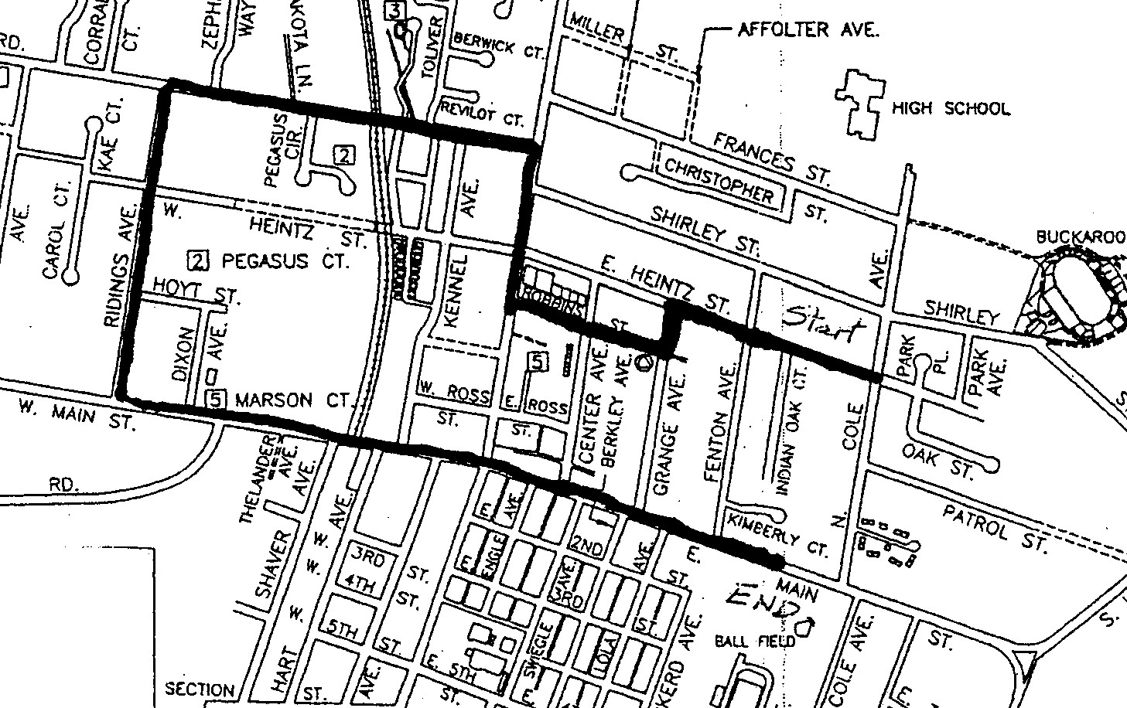

Theme: Small Town U.S.A.
Commercial ☐ $85.00 Community/Family/Church ☐ $50.00 Auto Clubs ☐ $30.00 Equestrian ☐ $25.00
Support Vehicles added to the main float will be $15.00 each and only one may be added.

Please check ONE entry in ONE category that most describes your entry.
± Indicates non-judged category.

Automobiles, Pickups - Proof of Insurance Needed (Upload at end of application)
Auto clubs will be charged $30.00 for the group and $10 for each additional vehicle.
☐ Vintage Car to 1955 ☐ Classic Car 1956-1979 ☐ Rat Rod ☐ Auto Clubs # of vehicles _____
☐ Vintage Pickup to 1955 ☐ Classic Pickup 1956-1979 ☐ Rat Rod Pickup

Novelty/Miscellaneous
☐ Motorcycle/ATV ± ☐ Boats/Jet ski ± ☐ Golf Carts ± ☐ Custom/Novelty ☐ Hobby/Personal Tractor
☐ Military Vehicle ± ☐ Dignitaries ± ☐ Royalty (Auto) ± ☐ Bicycles ±

Trucks/Heavy Equipment/Specialty Rigs Proof of Insurance Needed (Upload at end of application)
☐ 18 Wheeler/Heavy Equipment/Specialty Rig ☐ Public Service Vehicles ☐ Commercial Tractor

Equestrian
☐ Royalty ☐ Costume ☐ Western ☐ Youth ☐ Horse Drawn ± ☐ Posse/Saddle Clubs/Drill Team ±
Age limitations: The Equestrian Youth Categories are for youth 16 & under. ALL EXCEPTIONS MUST BE APPROVED. Youth must be accompanied by an adult. Youth under age 10 must be led by an adult.

Posse/Saddle Clubs: An organized posse or saddle club.
Drill Team: Group of riders who perform choreographed routines.
Horse Drawn: Any equestrian unit pulled by a horse or a team of horses.

Floats
☐ Commercial ☐ Community/Family ☐ Church

Band/Marching/Drill/Cheer
☐ Dance Teams/Drill Teams & Cheer ☐ Bands ± ☐ Military/Drill Teams ± ☐ Walking Units ±

Release of Liability

I desire to voluntarily participate in the 4th of July Molalla Giant Street Parade (the “Parade”) upon my own initiative, risk and responsibility. In consideration for permitting me to participate in the Parade, I hereby release and forever discharge the Molalla Area Chamber of Commerce, Sponsors, the Molalla Buckeroo Association, the City of Molalla, their officers, agents, their individual and business members, their successors and assigns (collectively the “Released Parties), acting officially or otherwise, from any and all claims, demands, actions or causes of action (a “Claim”), on account of my death, injury of loss of any sort, or on account of the death or injury to any family member or any animal owned by me which may occur as a result of or arise from my participation in or preparation for the parade, regardless of how arising, including any such Claim resulting from the negligence of a Released Party.

This release also includes any Claim for damage or loss of any vehicle, trailer, horse or float owned, managed, or operated by me and includes any preparation for the Parade, any movement to, from, or during the Parade.

I further represent that any vehicle, trailer or float that I enter and/or operate in the Parade is safe with no known mechanical or safety defects, for which I will inspect. I will not operate, nor will I allow the operation of any vehicle, trailer or float owned or operated by me in an unsafe or reckless manner.

If my entry includes animals, I agree the animal(s) will be kept under control at all times, before, during and after the Parade. I am aware that any animal(s) can be removed from the Parade by any Fire Department Representative, Parade Official, or Public Safety Officer for any reason, including if the animal is deemed to be out of control or a danger to any other participant and/or spectator.

I further represent that I will defend, indemnify and hold harmless the Released Parties, acting officially or otherwise, from all Claims, demands, actions or causes of action which may arise or result from or out of my/our participation for Parade activities, including but not limited to, Claims from any person who rides in or on or around my vehicle, trailer, horse and/or float. This release is binding on my heirs, successors, assigns, executors, administrators and personal representatives.

I have read and understood the above Agreement and agree to abide by the terms set forth.

Click or tap here to enter text. Click or tap to enter a date.
Printed Name | Date

Click or tap here to enter text. Click or tap to enter a date.
Signature (Typed name is your electronic signature) | Date

Click or tap here to enter text. Click or tap to enter a date.
Parent or Guardian of minor | Date
Rules and Regulations

Please initial beside each of these rules, even if you think they do not apply to you. These must be returned with your application form.

Application: Filled out completely. One category is chosen. Liability Release is signed.
Insurance: Proof of Insurance is included for truck and autos.
Drivers: All towing vehicles, autos, trucks or equipment will be operated by a licensed adult +21.
Entry Check in: Entry Number will be displayed.
Attendance: All parade entries must be attended at ALL times.
Participants: Participants may not get on or off floats, horses, tractors or other conveyances for the entire parade drivers must remain in vehicle they are driving.
NO stopping to perform: All entries must stay within 30 feet of each other. Entries must be moving forward, motion must be maintained.
Searches: All entries are subject to searches within reason by the Molalla Police or other Law Enforcement Agency.
Fireworks/poppers: No fireworks or poppers are allowed.
Firearms or projectile weapons: No firearms or projectile weapons of any type real or “play” (including water, nerf or air soft guns are allowed. The only exceptions will be firearms carried by a recognized miliary honor guard or active, recognized U.S. Military personnel with a special permit issued by the Molalla Police Department.
No Flammables: Entries may not emit any flame or flammable substances.
Tractors/Mowers: Any unit equipped with a mower deck must have the deck locked in place and blade disengaged.
ATV & Motorcycle Limitations: Operator/driver must be a legally licensed driver or person over age 16 with proof of training in an accredited ATV course. Helmets must be worn at all times.
Motorized “toy” vehicles operated by children age 15 and under must be equipped with a remote control power kill switch. An accompanying parent must be in physical control of said remote at all times. Proof of the kill switch and workability must be demonstrated the morning of the 4th or the entry will not be allowed to proceed in the parade. Entry must be able to travel the entire parade route and maintain a speed up to 3 miles pe hour.
No excessive speed: At no time may there be a display of excessive speed or power by any motor vehicle.
Dogs: Dogs must be kept on a leash at all times and under the control of their handler. Those not under control are subject to removal.

Business Name: Click or tap here to enter text.

Contact Name: Click or tap here to enter text.

Mailing Address: Click or tap here to enter text.

City, State, Zip: Click or tap here to enter text.

Phone Number: Click or tap here to enter text.

Email Address: Click or tap here to enter text.

Signature: I acknowledge the receipt of the attached rules and regulations and agree to comply.

Click or tap here to enter text. Click or tap to enter a date.
Signature (Typed name is your electronic signature) Date

Make checks payable to:
Molalla Area Chamber of Commerce
109 E. Main St. / PO Box 472
Molalla, OR 97038
503-829-6941
macc97038@gmail.com

Application will be processed after receipt of completed applications, proof of insurance and receipt of payment.
Payments may be mailed, dropped off or paid on our website.
Link to pay online: https://www.molallachamber.com/chamber-store

I paid my entry fee on: Click or tap to enter a date. Payment Method: Choose an item.
Arrival & Exit/Departure Instructions

YOU MUST HAVE YOUR ENTRY NUMBER DISPLAYED.
Check in with your Entry Number.
(Replacements are $5.00 at the check in location)

CHECK IN:
Begins at 6:30 am – Closes at 8:45 am
(Entries wishing to be judged must arrive by 8:00 am)
at Bohlander field across from Buckeroo Grounds on Shirley St.
ALL VEHICLES, TRAILERS, ETC. NOT IN THE PARADE MUST BE PARKED IN THE HIGH SCHOOL PARKING LOT.
Participants may be dropped off at the gate on Shirley Street.
You will be directed to line up in the lane for your entry type.
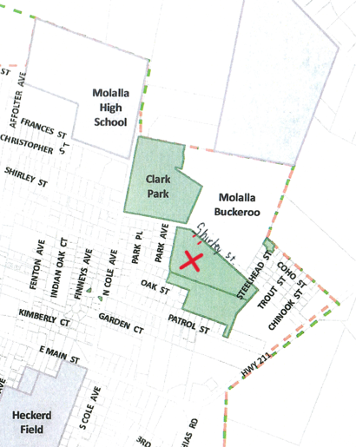

DEPARTURE

The Parade ends on Main St. as you approach the grass parking lot of Heckard Field just before Cole St.
You will not have access to Bohlander field after the parade, with the exception of equestrian entries.
You may go back to the High School parking lot if needed.
LINE-UP INSTRUCTIONS
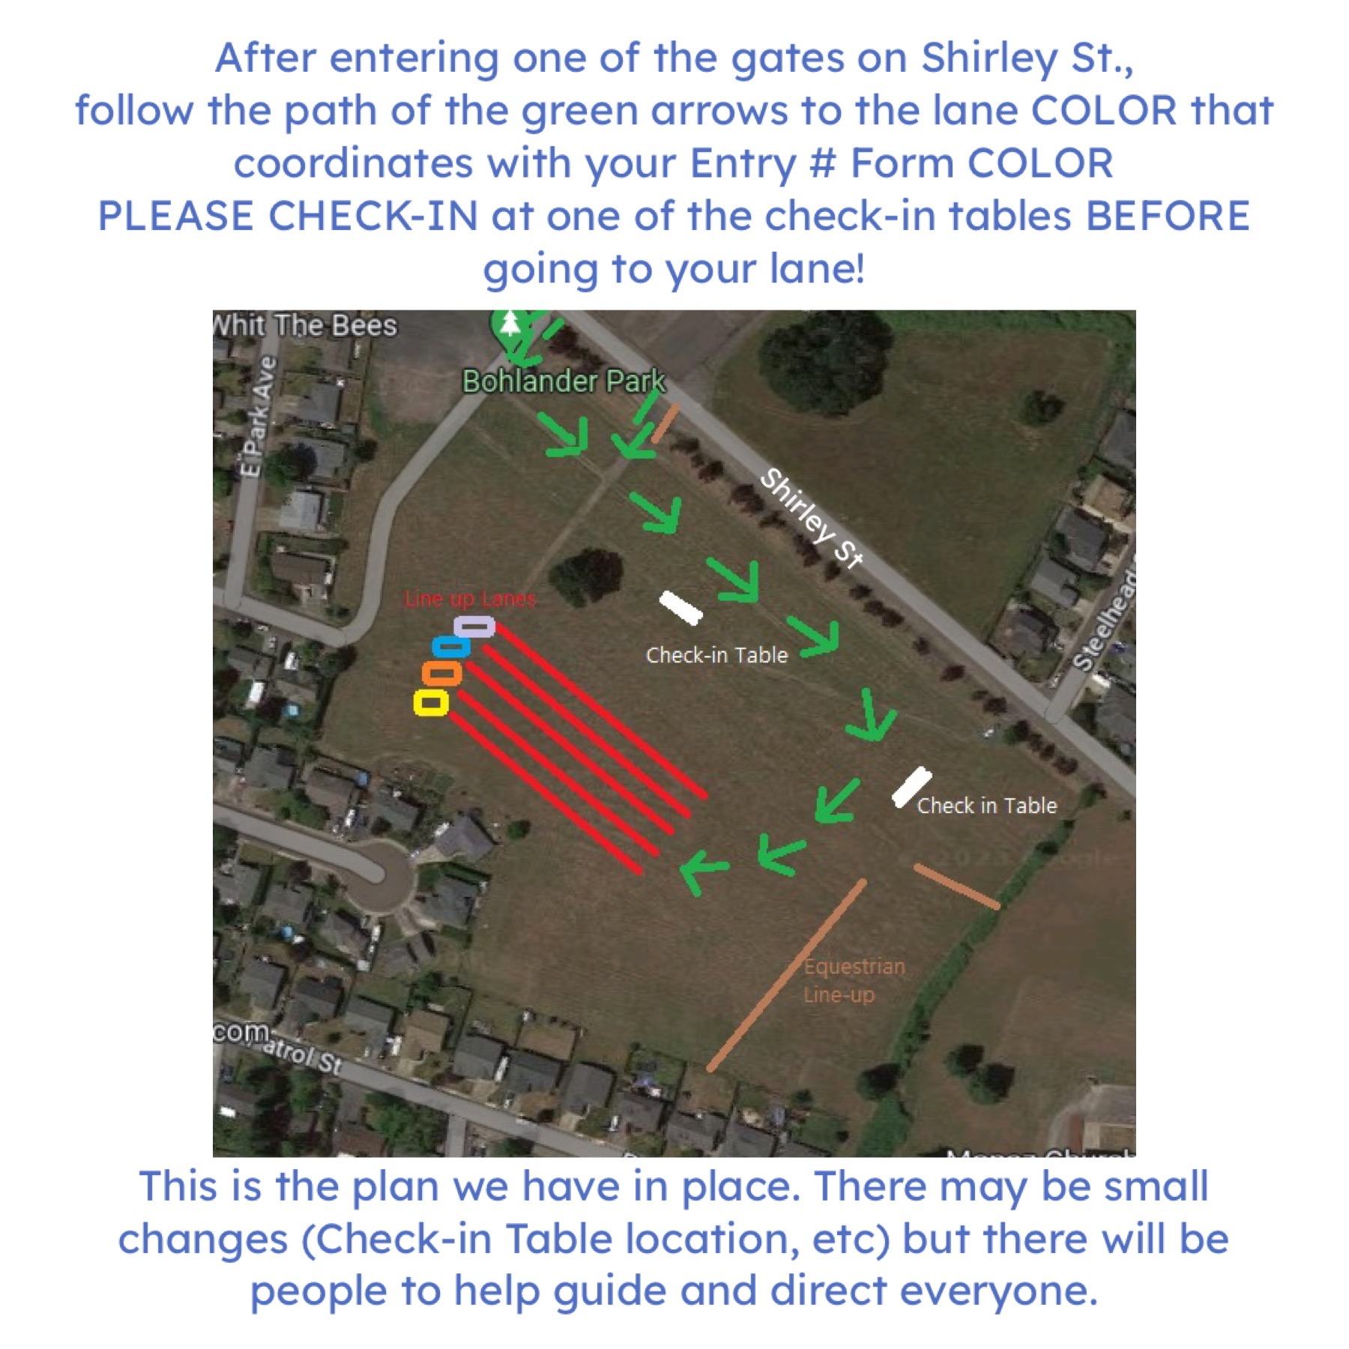

Proof of Insurance

Commercial: Upload Certificate of Insurance

Car or Truck: Upload Insurance Card

